// DEEPIKA SHARMA -124959
LAB 1 : DATA QUERY LANGUAGE
- Retrieve the details (Name, Salary and dept code) of the employees who are
working in department 20, 30 and 40.
Ans. REFER TABLE: Staff_Masters
SELECT
STAFF NAME, STAFF_SAL, DEPT_CODE FROM STAFF_MASTERS WHERE DEPT_CODE = 20 OR DEPT_CODE = 30 OR DEPT_CODE = 40
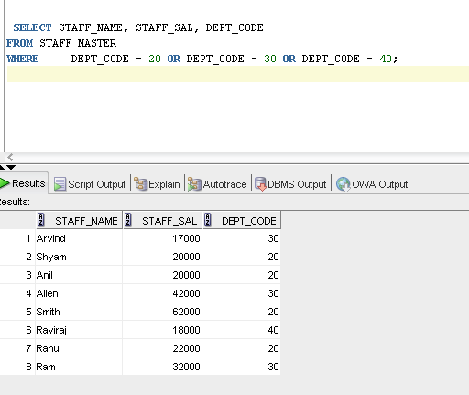

- List the details of the employees with user defined Column headers.
Ans. REFER TABLE: EMP
SELECT EMPNO E_N0 ,ENAME E_NAM,JOB E_JOB,MGR E_JOB,HIREDATE E_HIRE,SAL E_SAL,COMM E_COMM, DEPTNO E_DEPNO
FROM EMP;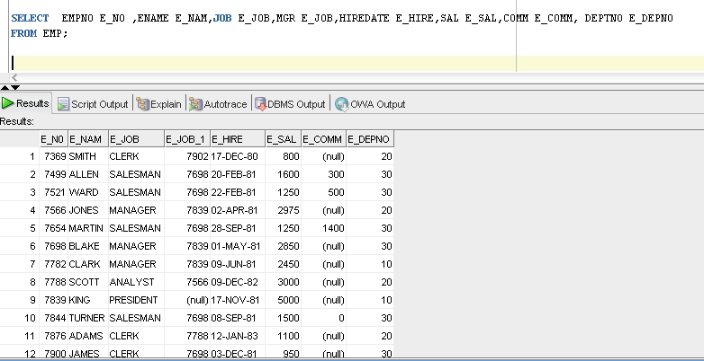

- Display the code, subjects and total marks for every student. Total Marks will be
calculated as Subject1+Subject2+Subject3.
Ans. REFER TABLE : Student_Marks
SELECT STUDENT_CODE , SUBJECT1, SUBJECT2, SUBJECT3 ,
SUBJECT1 + SUBJECT2 + SUBJECT3 TOTAL_MARKS
FROM STUDENT_MARKS;
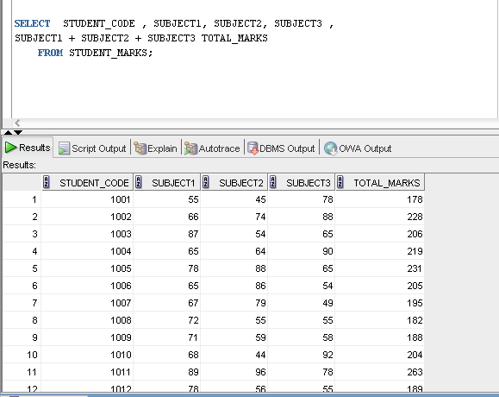
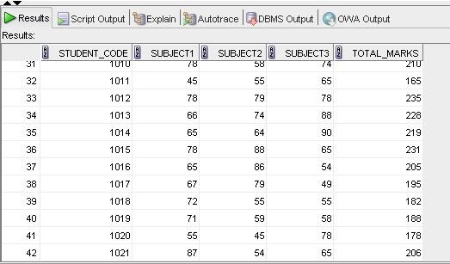

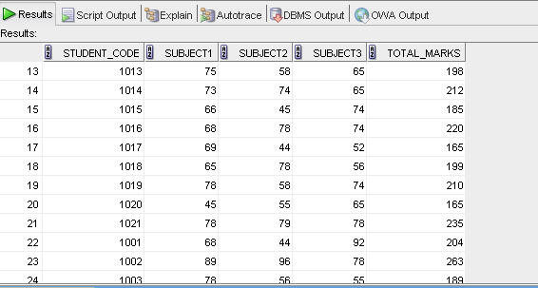

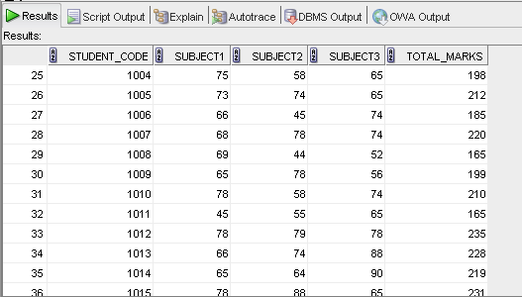

- List the details of the staff whose designations are either PROFESSOR or
LECTURER.
Ans. REFER TABLE : Designation_Masters
SELECT DESIGN_NAME,DESIGN_CODE
FROM DESIGNATION_MASTER
WHERE DESIGN_NAME = 'Professor' OR DESIGN_NAME = 'Lecturer';
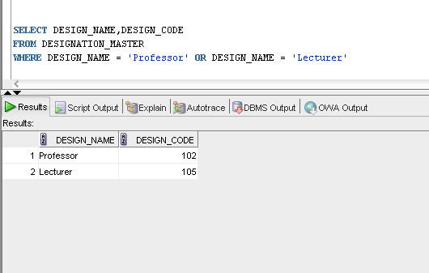

- List the code, name, and department number of the employees who have
experience of more than 18 years
Ans. REFER TABLE: Staff_Masters

select deptno,ename,empno
from EMP
where (sysdate-hiredate)/365 > 18;
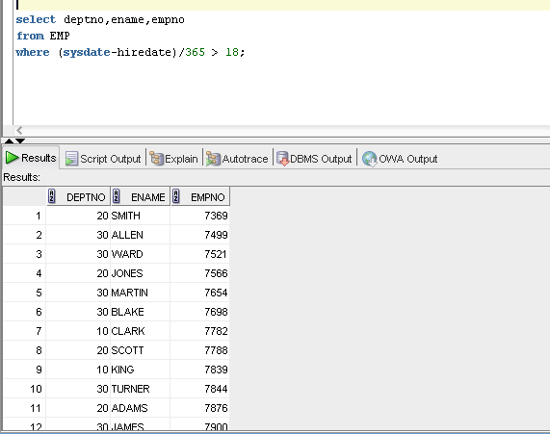
- List the name and Designations of the staff who have joined before Jan 2003.
Ans. REFER TABLE: Staff_Masters
SELECT DESIGN_CODE ,STAFF_NAME
FROM STAFF_MASTER
WHERE HIREDATE<('01-JAN-2003');
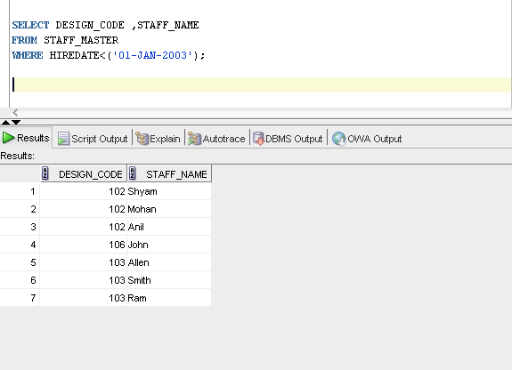
- List the name, designation, and income for 10 years of the employees who are
working in departments 10 and 30.
Ans. REFER TABLE: Staff_Masters
SELECT EMPNO, ENAME, SAL * 10 AS INCOME
FROM EMP
WHERE
(SYSDATE-HIREDATE)>=10 AND DEPTNO=10 OR DEPTNO=30;
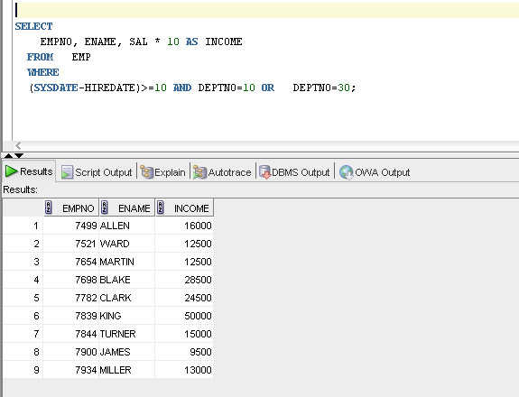
- List the name and experience (in years) of employees who are working as
LECTURER.
Ans. SELECT S.STAFF_NAME, d.design_code, s.design_code extract(year from sysdate))-extract(year from hiredate) as experience
FROM STAFF_MASTER S, designation_master D
WHERE S.DESIGN_CODE = D.DESIGN_CODE
AND DESIGN_NAME = 'Lecturer' ;
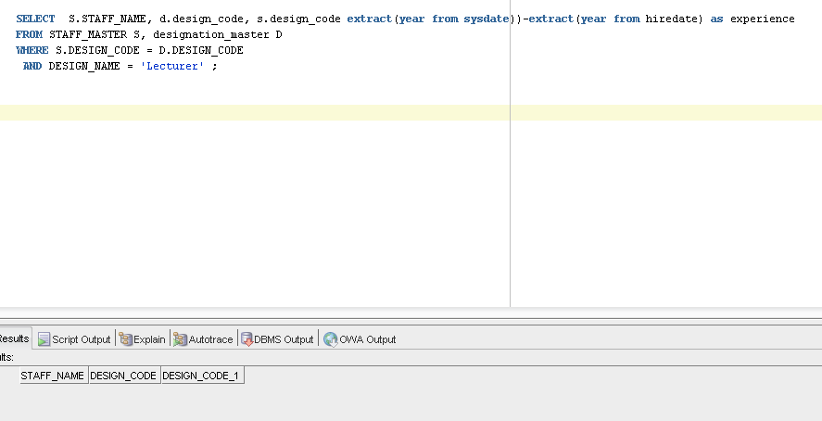

- Display name concatenated with dept code separated by comma and space. Name
the column as ‘Student Info’.
Ans. select student_name ||',' || dept_code as student_info
from student_master;

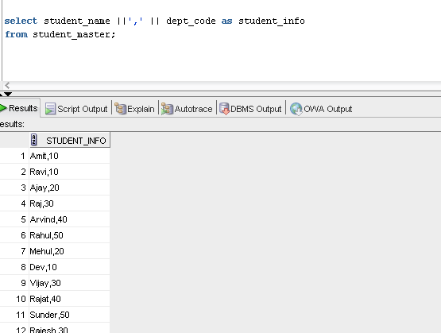

- List the Name and Salary of the staff who are earning between 12000 and 25000.
Sort them based on their salaries and name.
Ans. SELECT STAFF_NAME,STAFF_SAL
FROM STAFF_MASTER
WHERE STAFF_SAL BETWEEN 12000 AND 25000
ORDER BY STAFF_SAL ,STAFF_NAME;

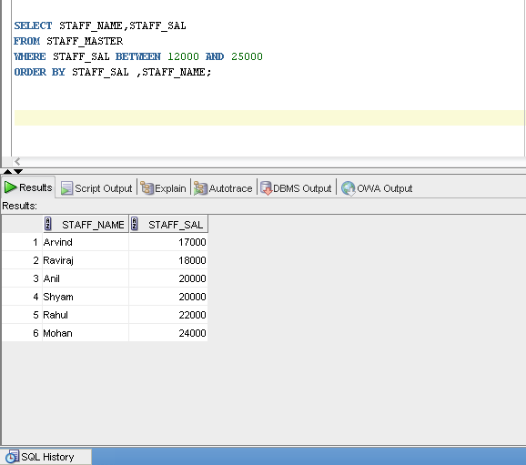

- Display employees who do not have manager.
Ans. 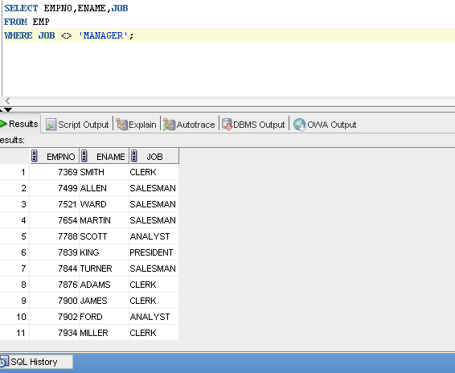

- Write a query which will display name, department code and date of birth of all
students who were born between January 1, 1981 and March 31, 1983. Sort it based
on date of birth (ascending).
Ans.
SELECT STUDENT_DOB
FROM student_master
WHERE STUDENT_DOB < '31-MAR-1983' AND STUDENT_DOB > '01-JAN-1981'
ORDER BY STUDENT_DOB;
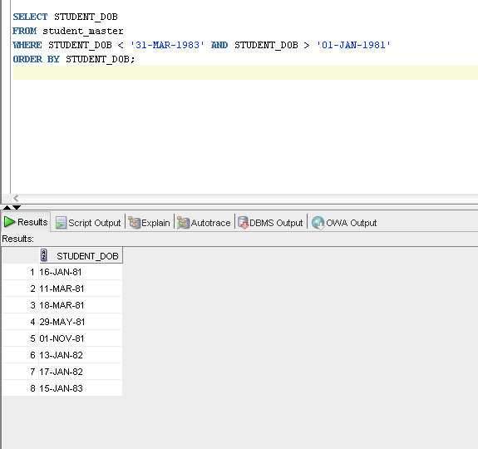
- Get the Department number, and sum of Salary of all non managers where the
sum is greater than 20000.
Ans.
- Display the details of books that have not been returned and expected return date
was last Monday.
Ans. SELECT *
FROM BOOK_TRANSACTIONS
WHERE TO_CHAR(book_expected_return_date, 'DY')='MON' AND book_actual_return_date >sysdate;
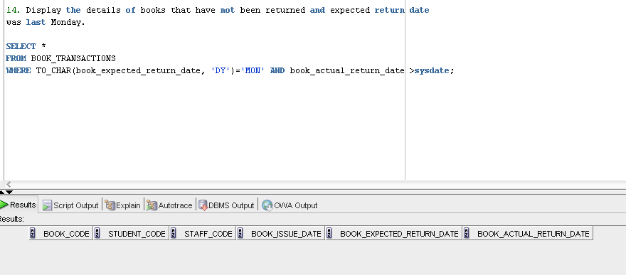
- Display the name and department code of students. If student does not belong to
any department, display “No Department”. Label the column as “Department”.
Ans. SELECT NVL(TO_CHAR(DEPT_CODE),'NO_DEPT') AS DEPARTMENT, STUDENT_NAME
FROM STUDENT_MASTER;
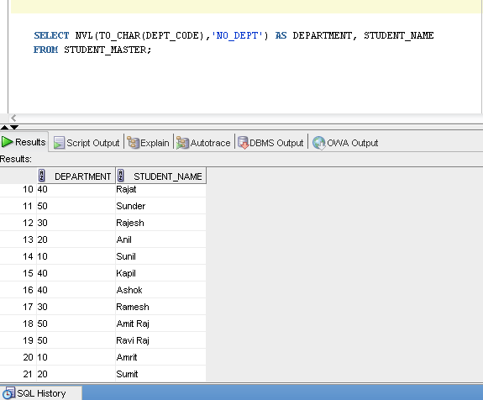

- Display the name and salary of the staff. Salary should be represented as X. Each
X represents a 1000 in salary.
Sample Output
JOHN 10000 XXXXXXXXXX
ALLEN 12000 XXXXXXXXXXXX
Ans.
select staff_name ,lpad('X',trunc(staff_sal/1000),'X')
AS STAFF_SAL FROM STAFF_MASTER;
